**CLP PROGRAMMING(Control Language)**

Functionalities of a CL program:

**To call program interactively or in batch mode.**

**To control the sequencing of those programs.**

**Process files and other objects.**

**To monitor for all kind of messages.**

**To Make communication between different jobs.**

**Change the attribute of an object and then process it.**

**CL source program segments**

1. **PGM command**

**PGM PARM (&A)**

 PGM is an Optional part for the beginning of the CL program. But it becomes mandatory if we need to pass parameter to the CL program.

1. **Declare commands**

**(DCL, DCLF, COPYRIGHT)**

The declare commands must precede all other commands except the PGM command.

1. **INCLUDE command**

CL command to embed additional CL source commands at compile time

1. **CL processing commands**

**CHGVAR, SNDPGMMSG, OVRDBF, DLTF**

1. **Logic control commands**

**IF, THEN, ELSE, DO, ENDDO, DOWHILE, DOUNTIL, DOFOR, LEAVE, ITERATE, GOTO, SELECT, ENDSELECT, WHEN, OTHERWISE, ENDSUBR**

1. **Built-in functions**

**%SUBSTRING (%SST), %BINARY (%BIN), %ADDRESS (%ADDR), %CAT()**

1. **Program control commands**

**CALL, RETURN, TFRCTL**

1. **Procedure control commands**

**CALLPRC**

CL command to pass control to another procedure

1. **ENDPGM command(optional)**

**ENDPGM**

**Limitations of CL (comparison to RPG)**

·        We cannot use CL program to ADD or UPDATE records in database files.

·        It has limited printing capability.

·        It cannot use Program described files.

·        It doesn’t support subfile (to display more than one record), but a single output message subfile is a special type of subfile that is supported well in CL.

·        We cannot declare more than one object (file) in a CL program ( In CLLE, we can use more than 1 file to read with OPENID concept).

**OPNID in DCLF**

·         Open id is an identifier for any opened file in the CL program.

**DCLF       FILE(AMIT/ACCOUNT) OPNID(ID1)**

**\*CAT/*BCAT/*TCAT**

**\*CAT or || Joins two strings "as is"**

**\*BCAT or |> Joins two strings with a single blank space between**

**\*TCAT or |< Joins two strings trimming first string**

**'String One ' *CAT 'String Two ' Yields 'String One String Two '**

**'String One ' *BCAT 'String Two ' Yields 'String One String Two '**

**'String One ' *TCAT 'String Two ' Yields 'String OneString Two '**

**Multiple file read operation in CL**

If we want to use multiple files in the CL program, we need to use OPEN ID for this.

**PASSING THE PARAMETER IN CL**



**DSPMSG 🡪** to view the msg

CLR

**Open query file**

·         OPNQRYF command creates a temporary access path for a file and after its use the access path is discarded.

·         We change the access path of a file dynamically with the help of this command.

·         It can be used to select a subset of the available records, order the records, group the records, join the records.

·         Before we go through open query file we should understand open data path also.

**Open Data Path**

·         This is a temporary object which is used to create dynamic access path for a file.

·         Access path describes the order in which records are to be read.

·         Access paths can be kept on the system permanently (such as physical or logical file) or temporarily (OPNQRYF). OPNQRYF command creates a temporary access path for use one time, and then discard the access path.

·         The open data path contains the information like file name, format name, current record pointer, record selection information etc.

·         Open data path has only one cursor. Each program that shares the same ODP has only one image of the cursor. So if the cursor is repositioned in the called program then the cursor will still be pointing at the same repositioned record.

·         Languages other than CL cannot make dynamic access path or in other words cannot perform dynamic record selection. If we want other programs like RPG also to perform dynamic record selection, we can share the access path of the file (that we create in CL) with the RPG program.

·         To share the access path we create an open data path in our CL program with OPNQRYF command and then we share this ODP with the called RPG program. This sharing is done with the help of SHARE (*YES) in the OVRDBF command.

**Steps to create and use an  OPNQRYF**

     I.            OVRDBF

FILE (file PF) TOFILE (LIB/ PF) SHARE (*Yes)

II. OPNQRYF

**OPNQRYF    FILE(lib name/file name            +**

**Member-name              +**

**Record-format-name)      +**

**OPTION(open-option)               +**

**FORMAT(lib name/database file name  +**

**Record-format name)      +**

**QRYSLT(query selection)            +**

**KEYFLD(field name)**

The attribute of OPNQRYF is described below:

·         **FILE      :**  File to be processed.

·         **OPTION:**  In which mode the file is to be processed.

**OPTION(*INP   *OUT   *UPD   *DLT    *ALL)**

*ALL is combination of first four.

·         **FORMAT:** File format

·         **QRYSLT:**

**\*ALL**

**FILE (LIB / PF)  QRYSLT(*ALL)**

      It includes all records.

**\*BCAT**

**FILE (LIB / PF) QRYSLT (‘EMPNO *EQ ‘ *BCAT &A)**

       We can use *BCAT to insert the variable’s value in an expression with blanks in between.

**%WLDCRD**

  It is similar to %LIKE in SQL

**QRYSLT (‘PARTY_NAME  *EQ %WLDCRD (“S* “)’)**

       It will fetch all the records where party name starts from S.

**\*CT**

  It will fetch all the records, which contains the particular character.

**QRYSLT (‘PARTY_NAME *CT “S” ‘)**

        It will fetch all the records where party name contains the character ‘S’.

**%RANGE**

  It will fetch the records within the specific range

**QRYSLT (‘PARTY_NUM  *EQ  %RANGE (10000001 20000001)’)**

       It will fetch all the records where party number falls in the range 10000001 and 20000001.

·         **KEYFLD:**

**OPNQRYF    FILE(ACCOUNT)**

**QRYSLT(‘ CURRENCY = “USD” ’)**

**KEYFLD((ORG-CODE *DESCEND) (ACCOUNT))**

II.            CALL PGM (LIB/PGM-NAME) PARM ()

IV.            DLTOVR

 DLTOVR    FILE (OPNPF)

  V.            CLOF

CLOF    OPNID (OPNPF)

1. Calculator program - Program that accepts 2 numbers and an operator as input and display the result. Also validates the operator.

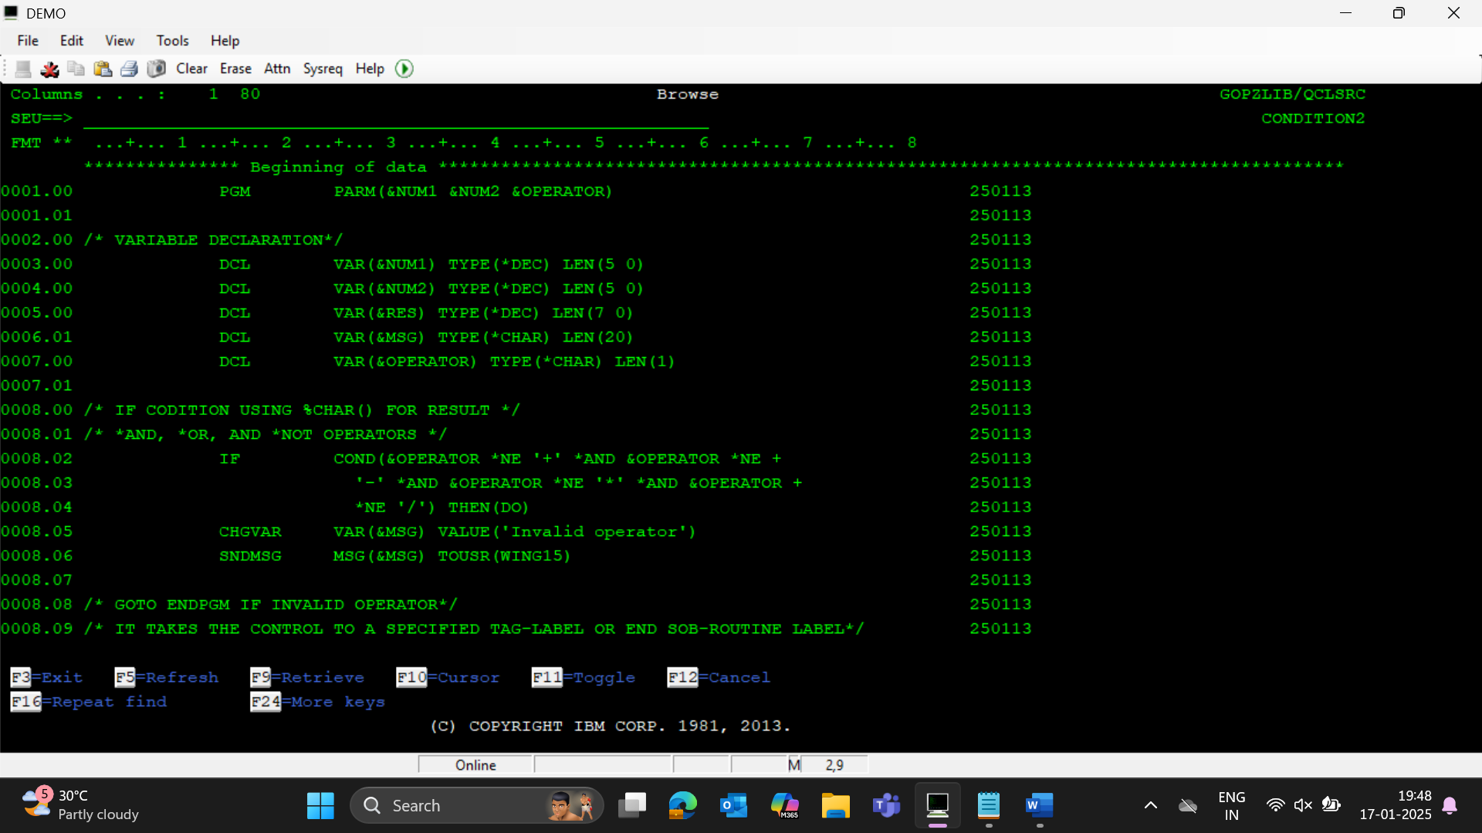

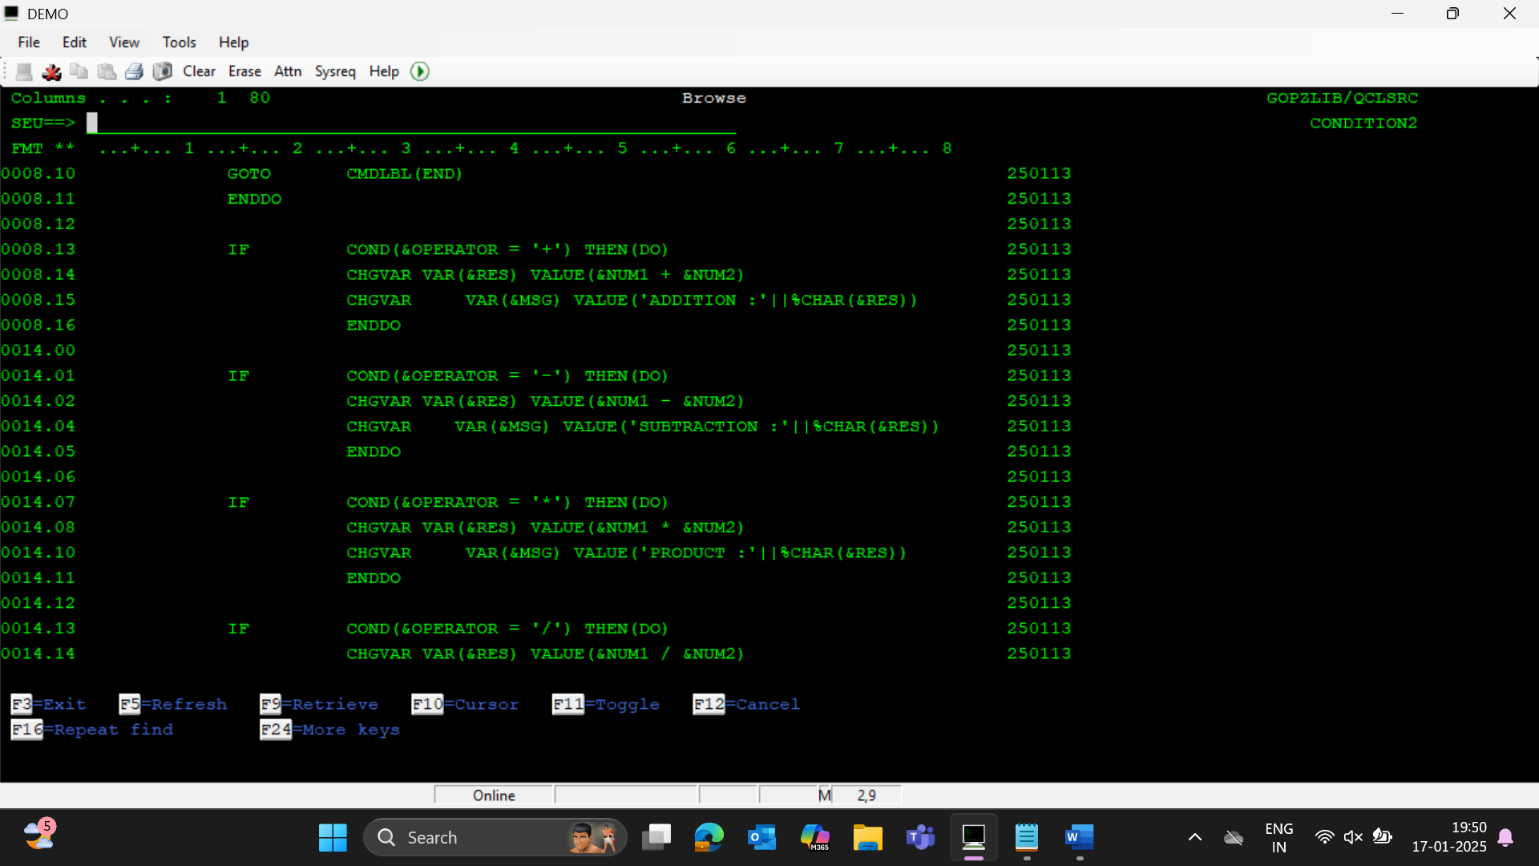

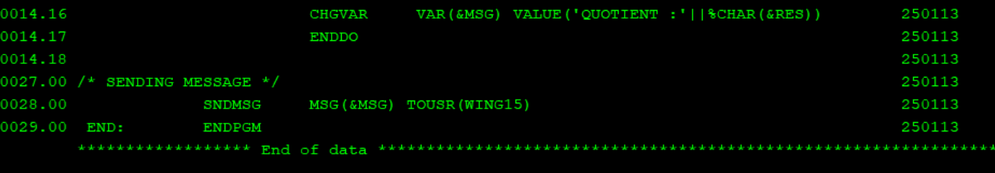

SNDMSG

RCVMSG

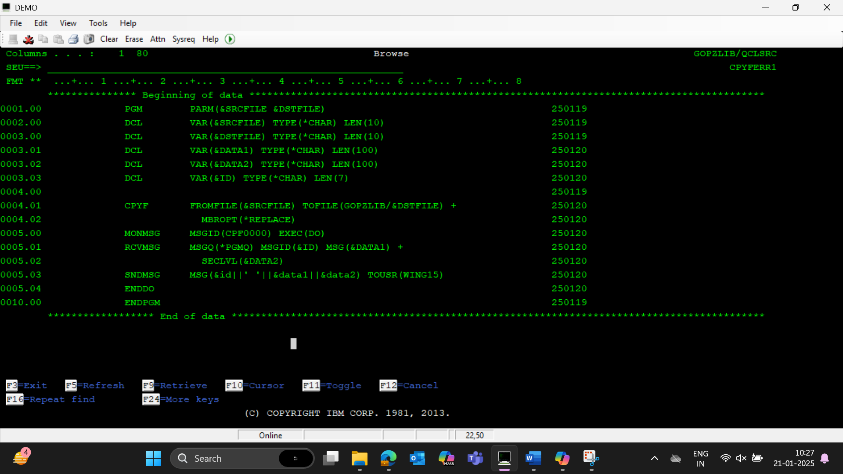

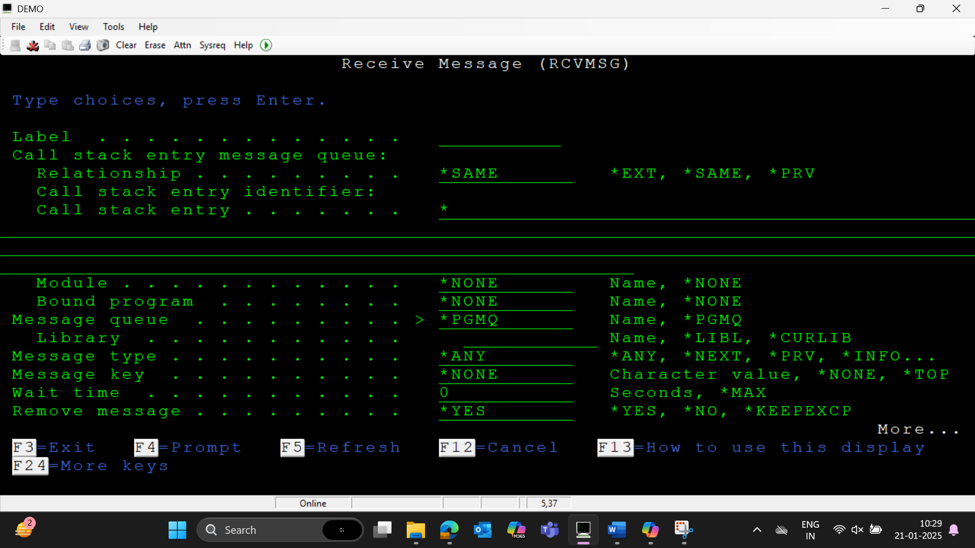

Give msgq as *PGMQ

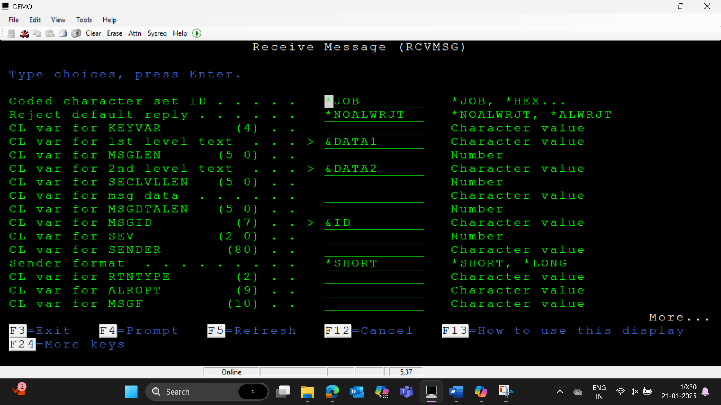

Give 1st lvl text 2nd lvl and msgid

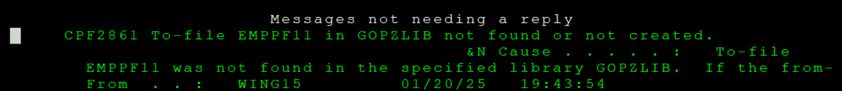

SNDBRKMSG

SNDUSRMSG & SNDPGMMSG

**SNDUSRMSG**: This command is used to send a message to a specific user or workstation. It can also be used to display a message on the user's screen.

**SNDPGMMSG**: This command is used to send a message to a program message queue. This is often used within applications to communicate information or errors between programs.

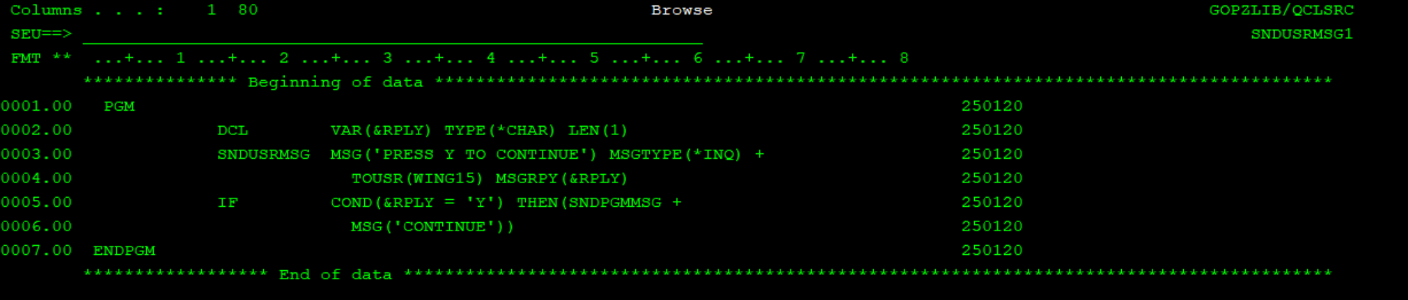

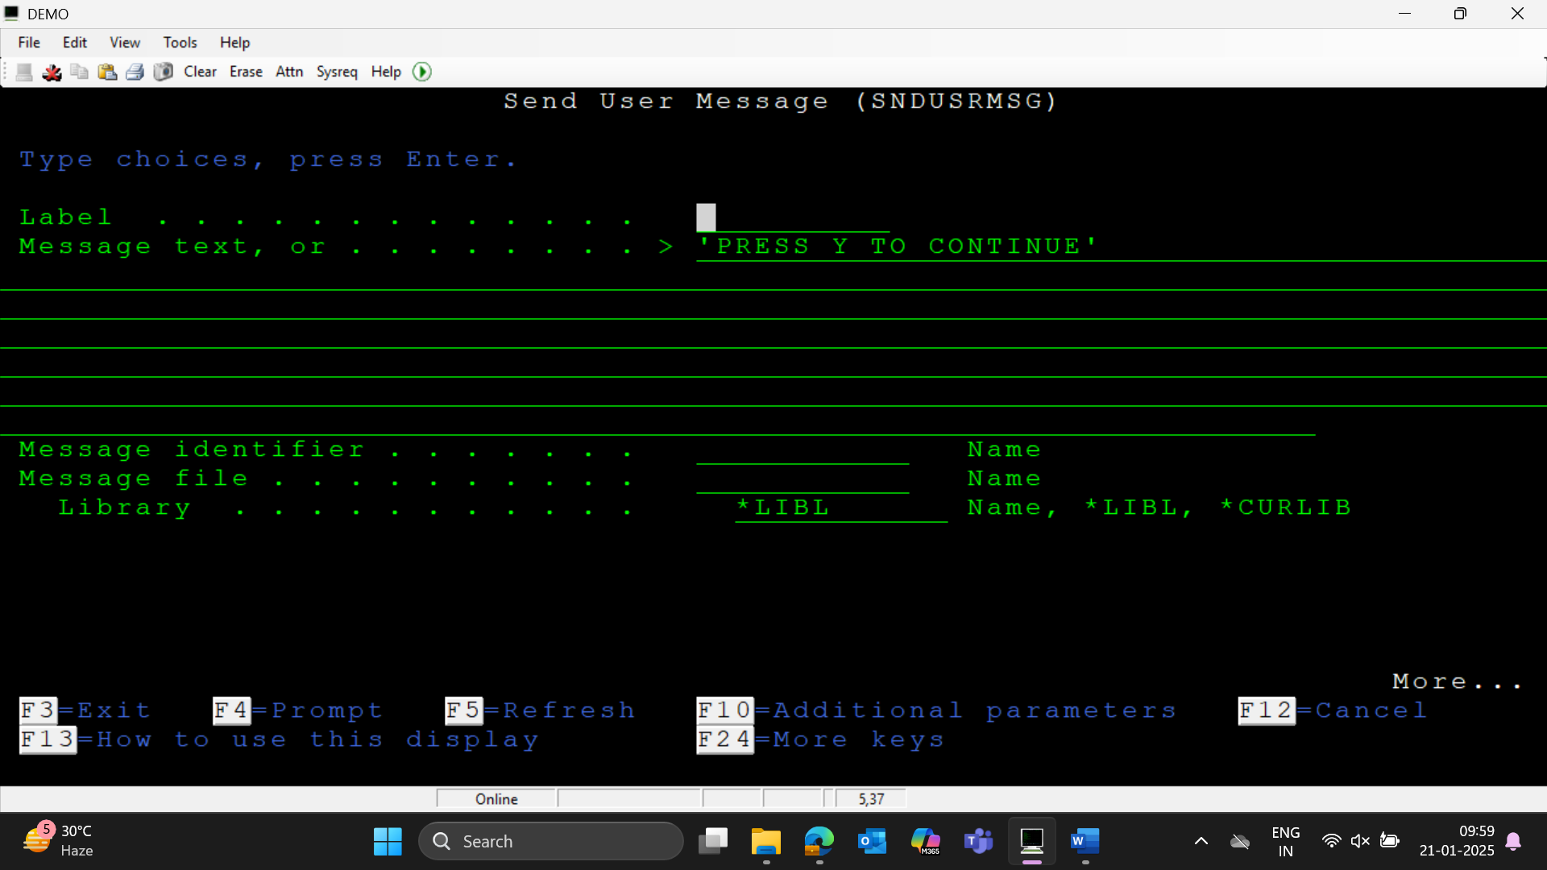

If msg is taken from some file we need to specify the message identifier and message file. Else, text is enough.

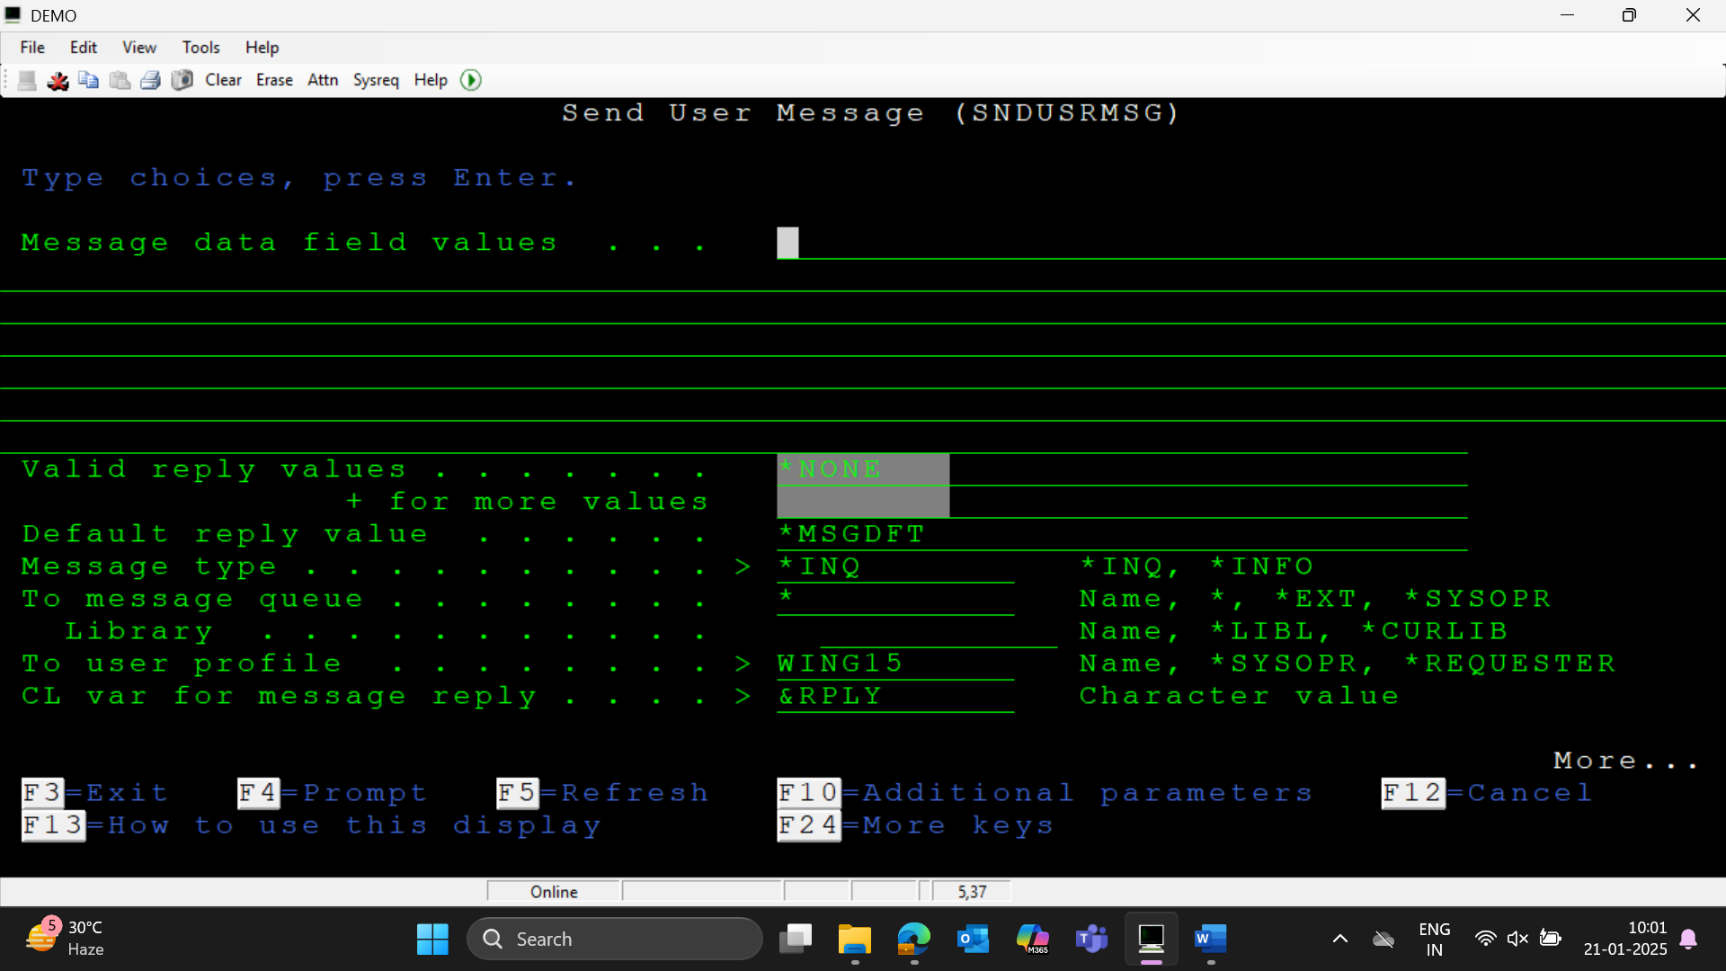

If we need to validate the replies we can provide the list in valid reply values field.

To get reply ,ie. For mandatory reply we need to give msg type as *INQ ,else you can give *INFO.

Specify the msg variable also

1. Calculator program - Program that accepts 2 numbers and an operator as input from screen and display the result. Also validates the operator.

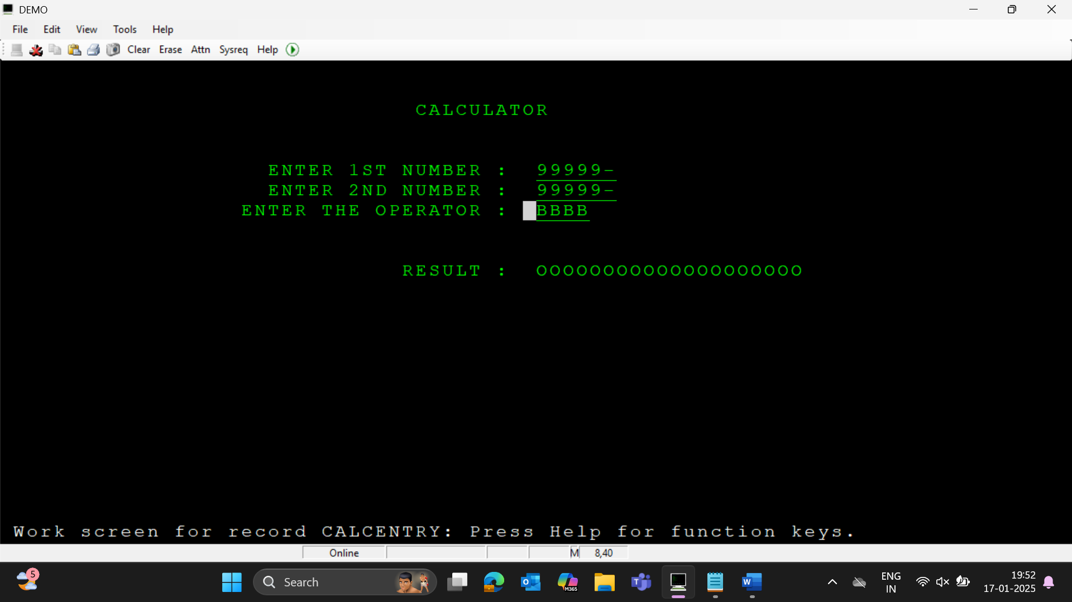

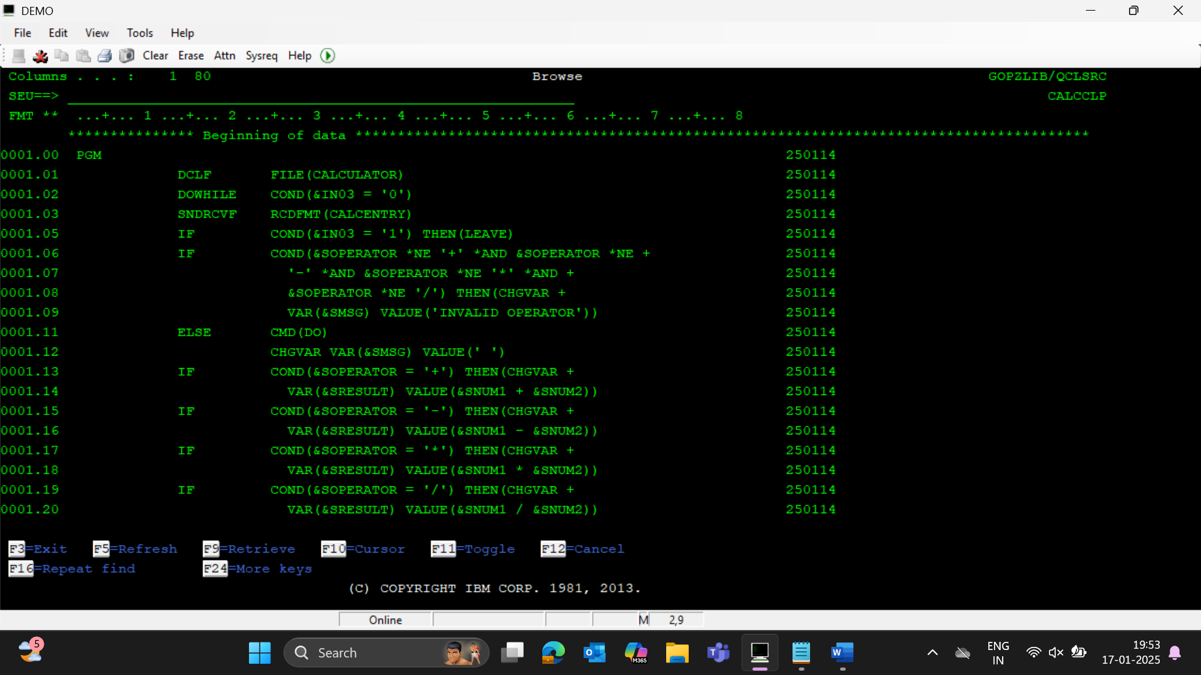

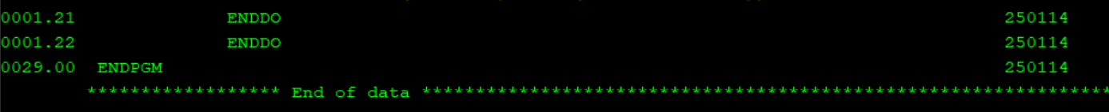

1. Finding greatest among the three numbers accepted as parameters

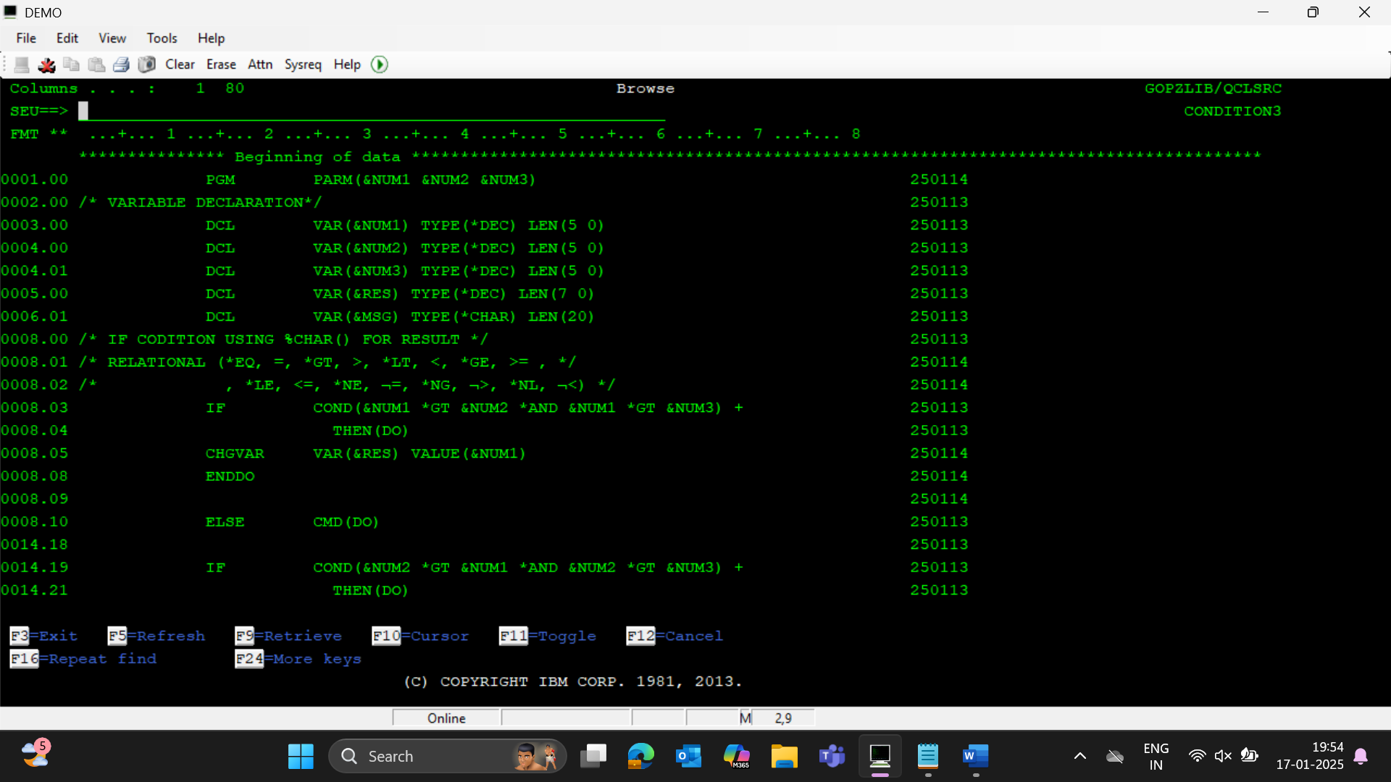

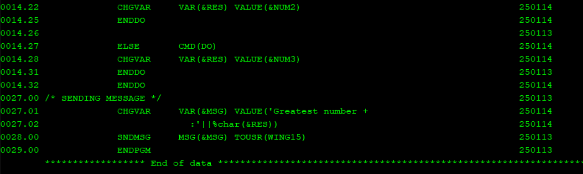

1. Retrieve data from data area with and without positions

To create data area 🡪 CRTDTAARA+F4

To view data area 🡪 DSPDTAARA+F4

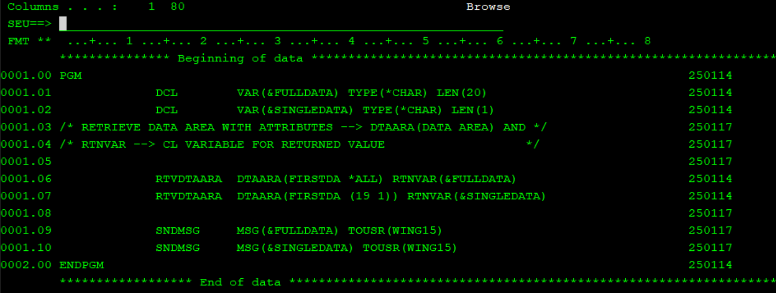

1. Program to retrieve system values

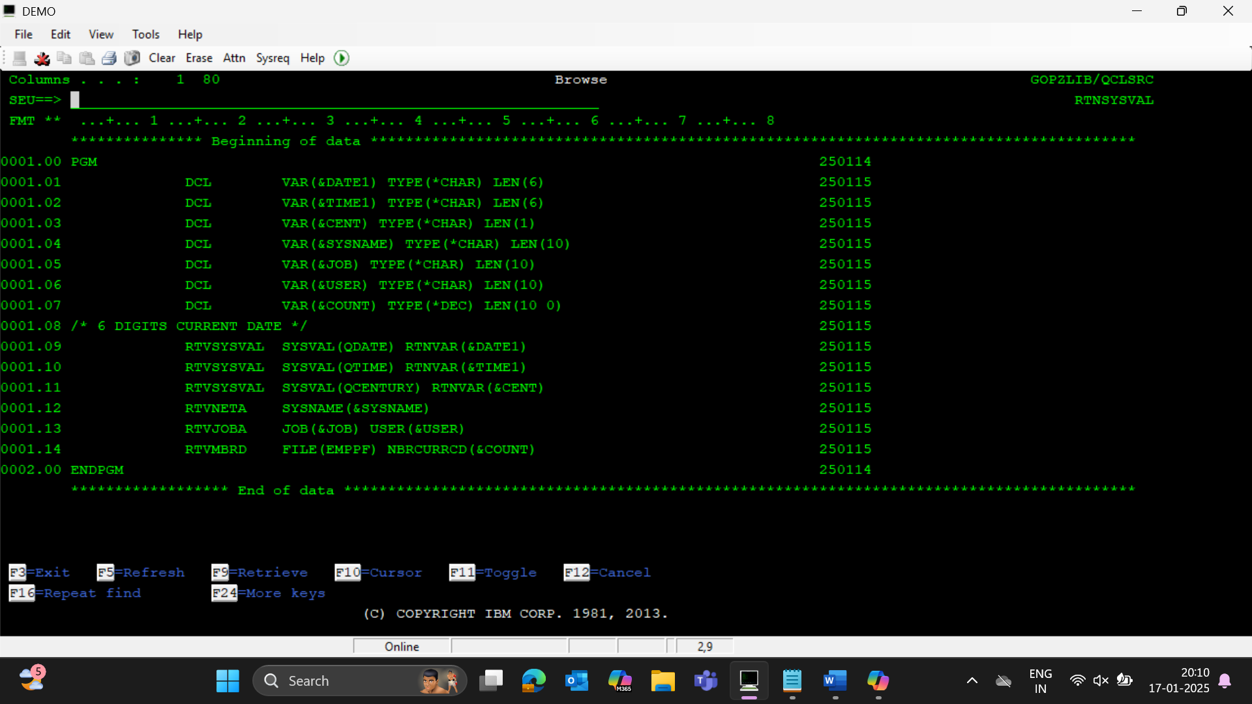

1. Program to implement the usage of string functions in CLP

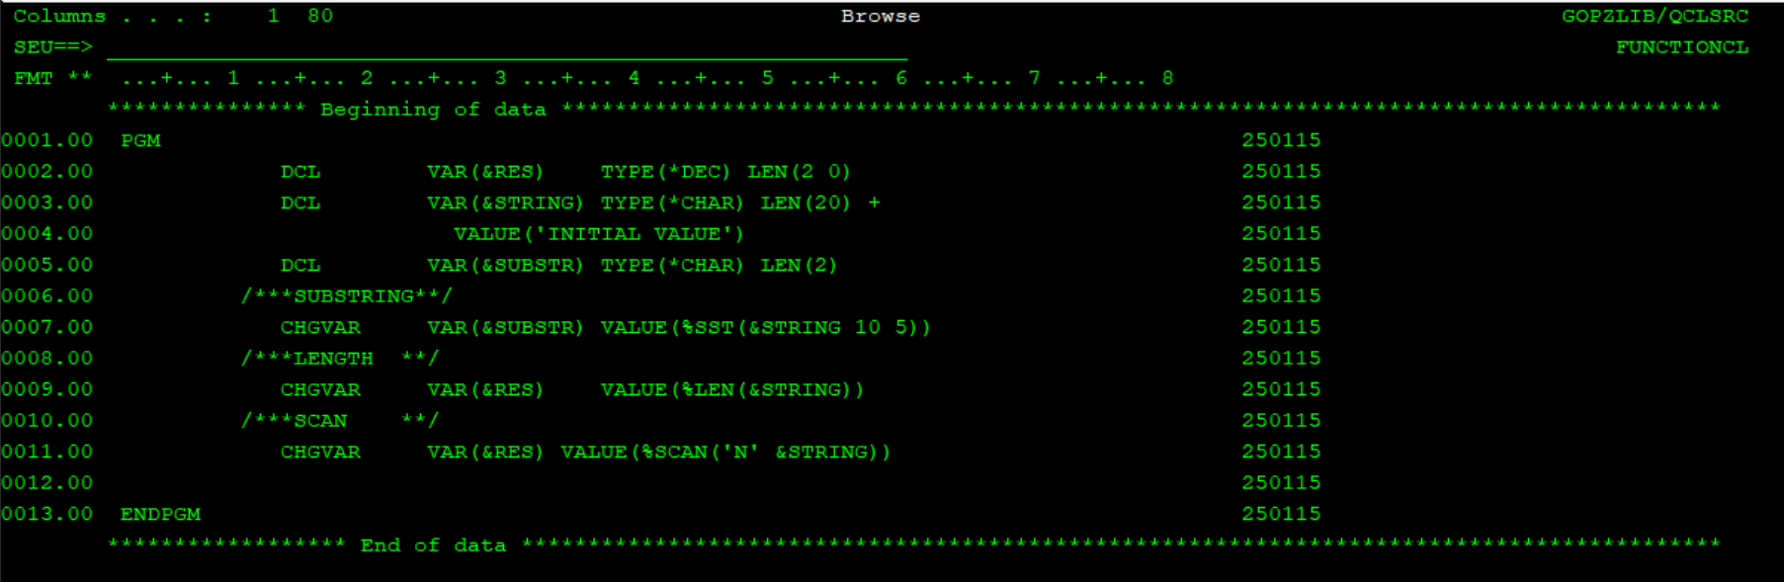

1. Program to implement PARM, GOTO, concatenation with pipes, *TCAT

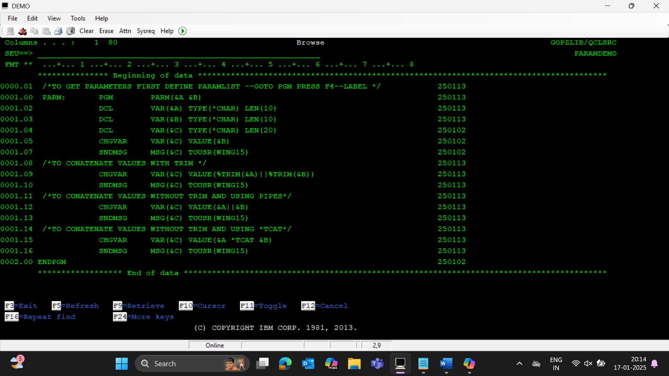

1. Program to read deptname from deptpf

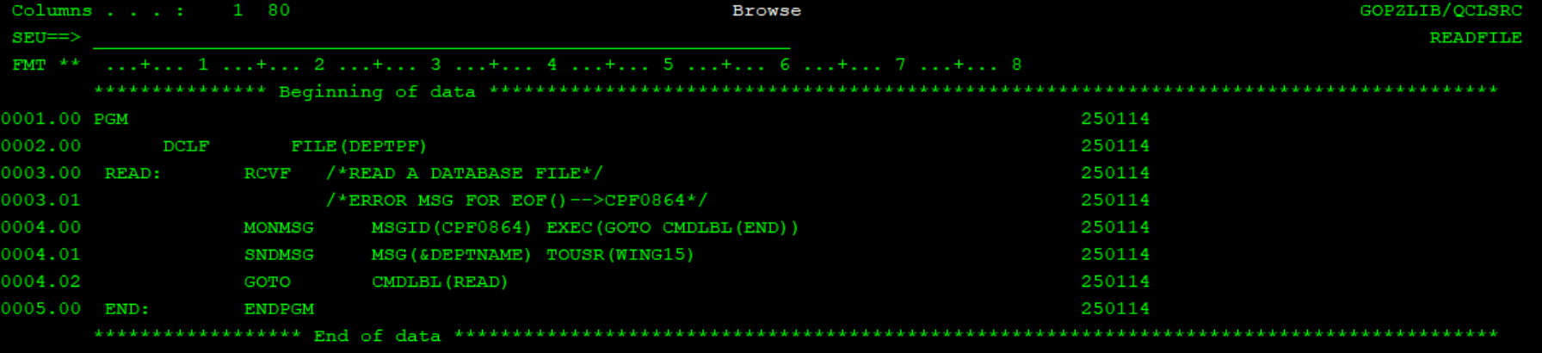

1. Program to count number of employees in a given city passed via param

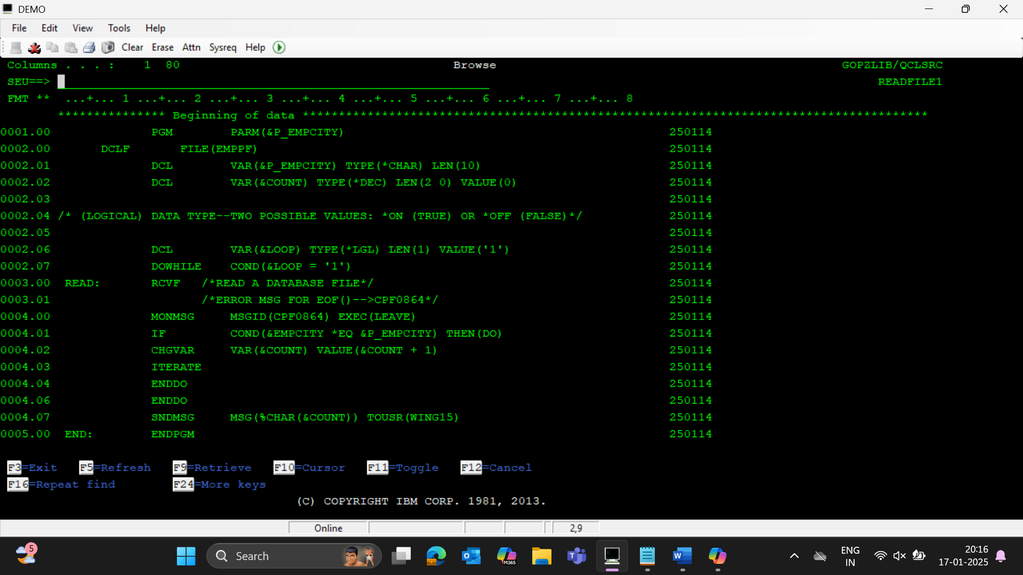

1. Program to count num of employees in each city

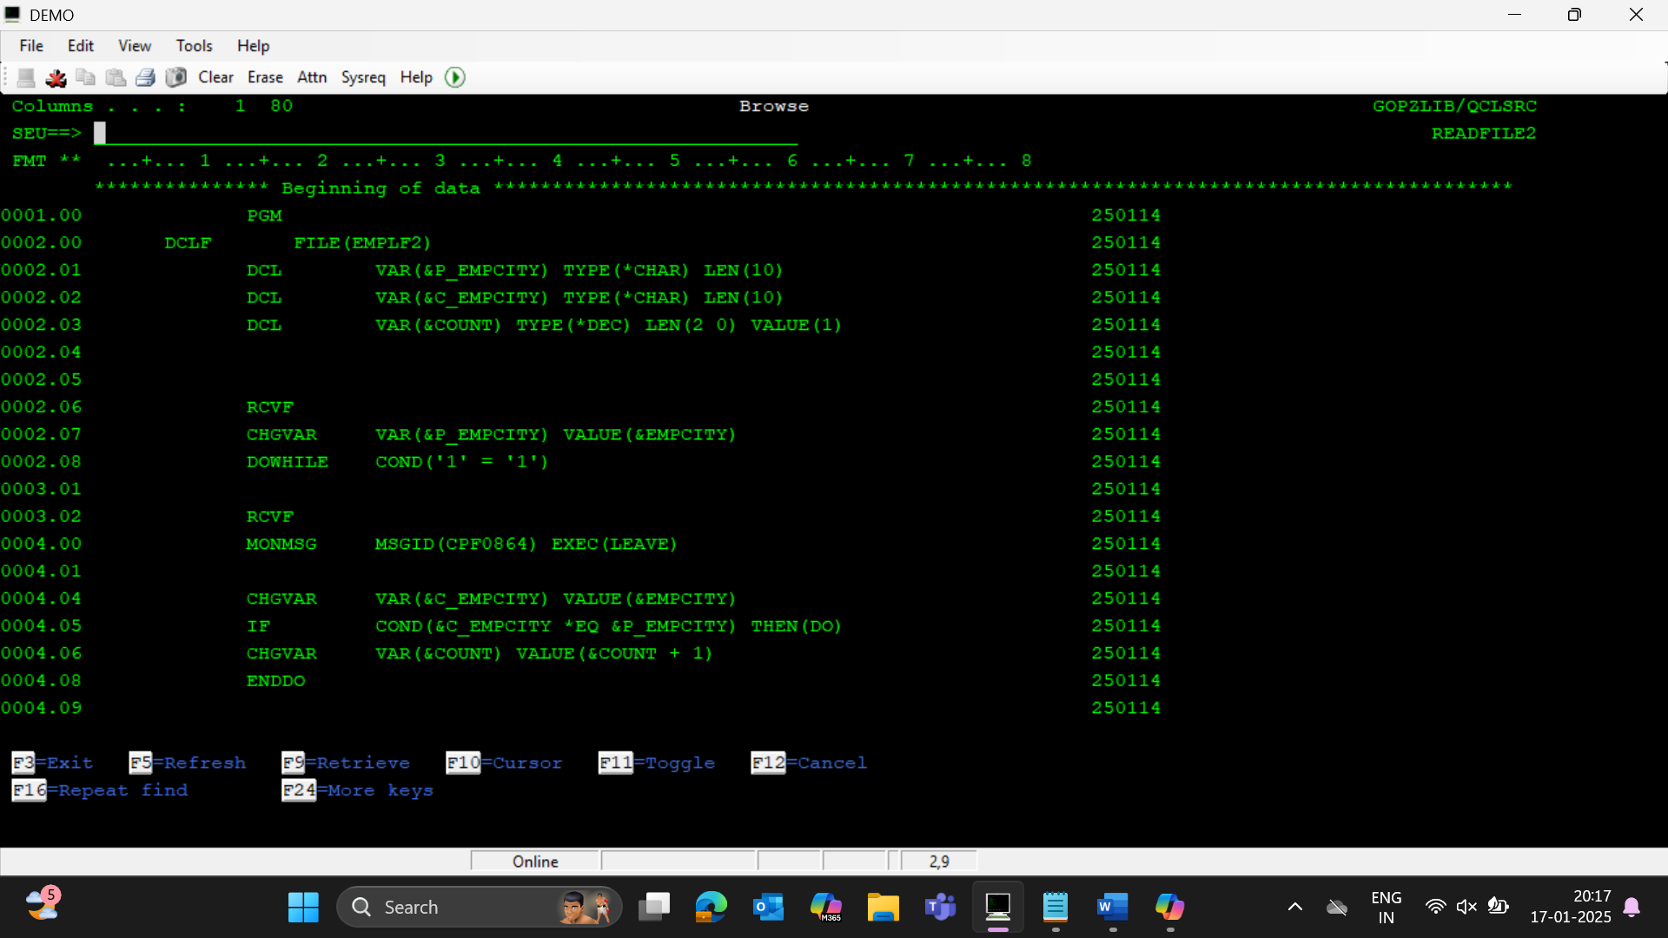

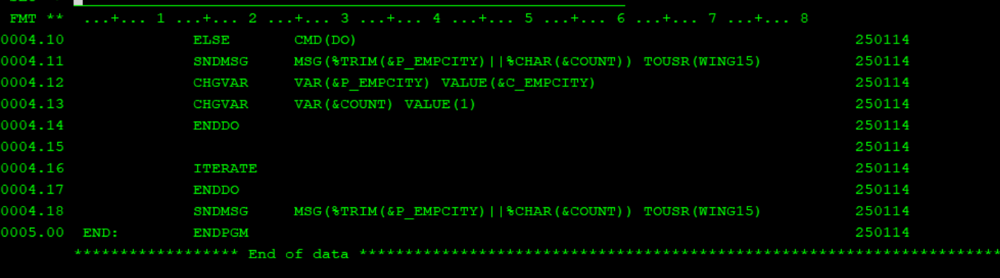

1. create citypf with field city , create cl program to read city pf and it should generate report for each city by submitting rpgle report program in batch using sbmjob command.

Job name should be seperate for each city

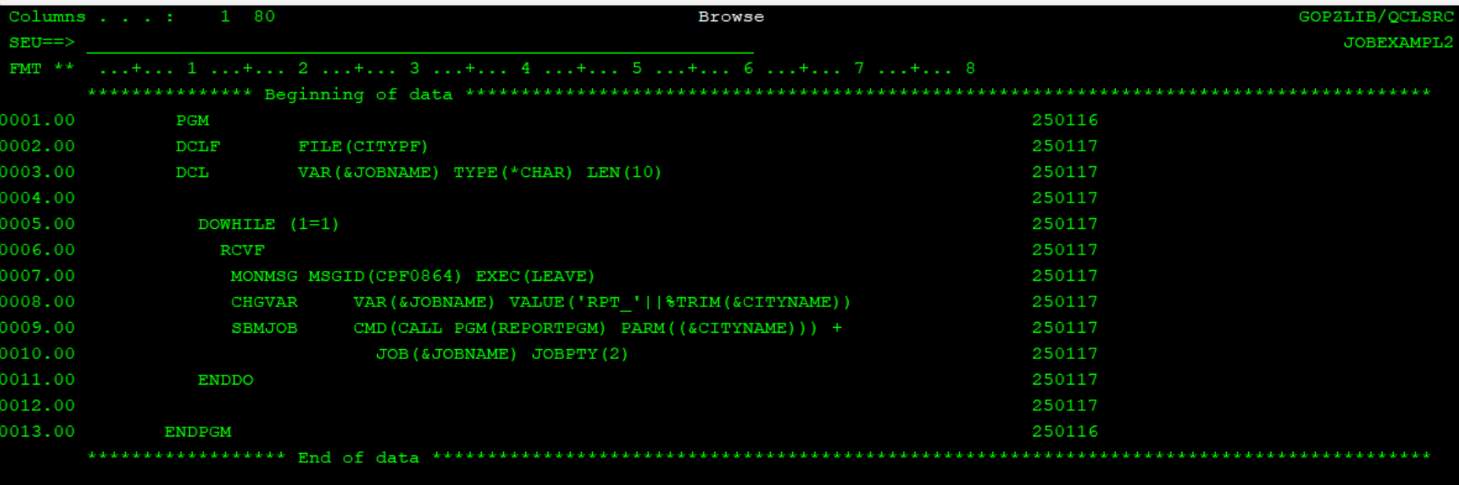

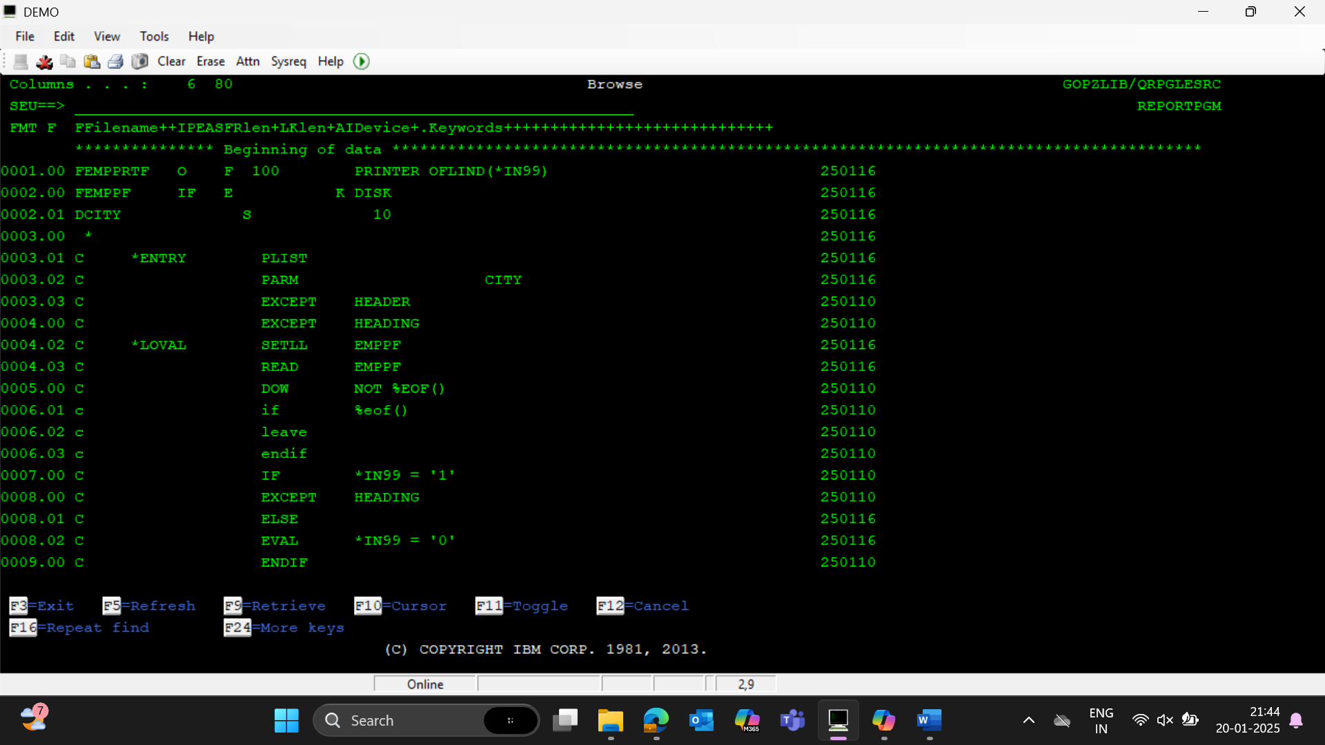

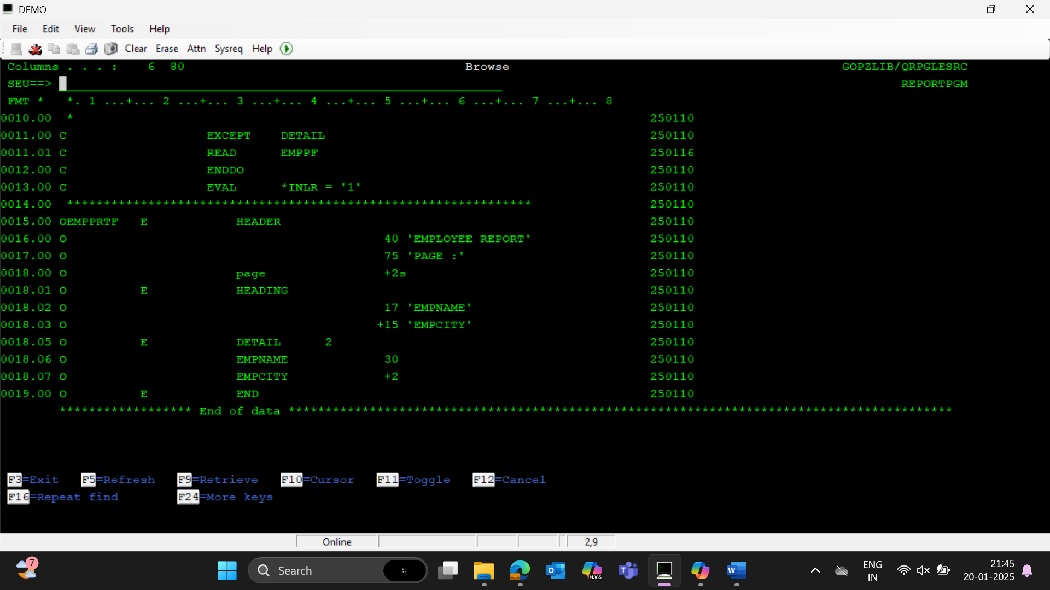

1. create a cl program to accept source file and destination file as parameters ,program should copy data from source file to destination file , if destination file doesn't exist cpy command should be executed by creating file.

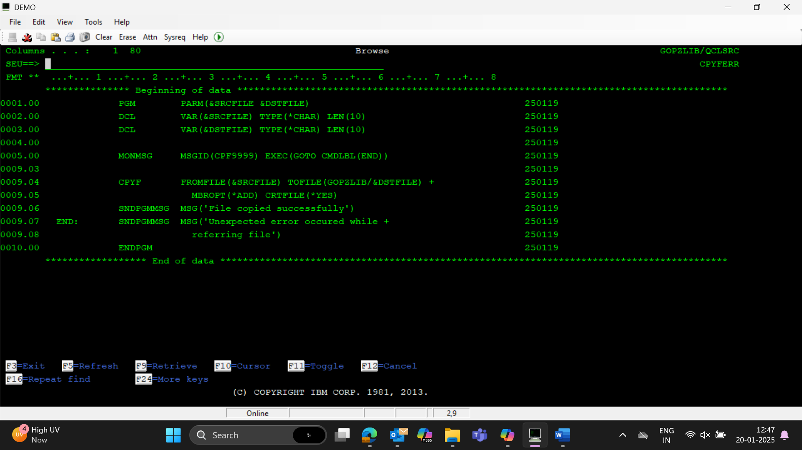

1. create a cl program to accept source file and destination file as parameters ,program should copy data from source file to destination file , if destination file doesn't exist cpy command should be executed by creating file – flatfiles

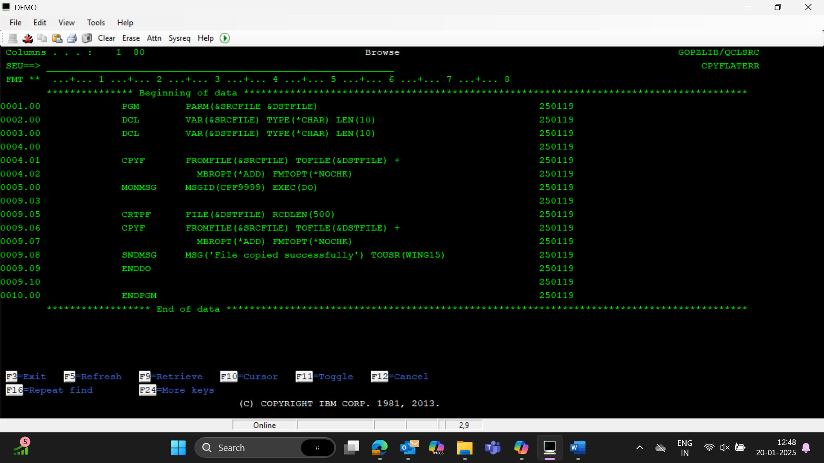

1. create a clp program to get city as parameter and copy records for that city from EMPPF in output file emppf10 (output file can have same structure as emppF)

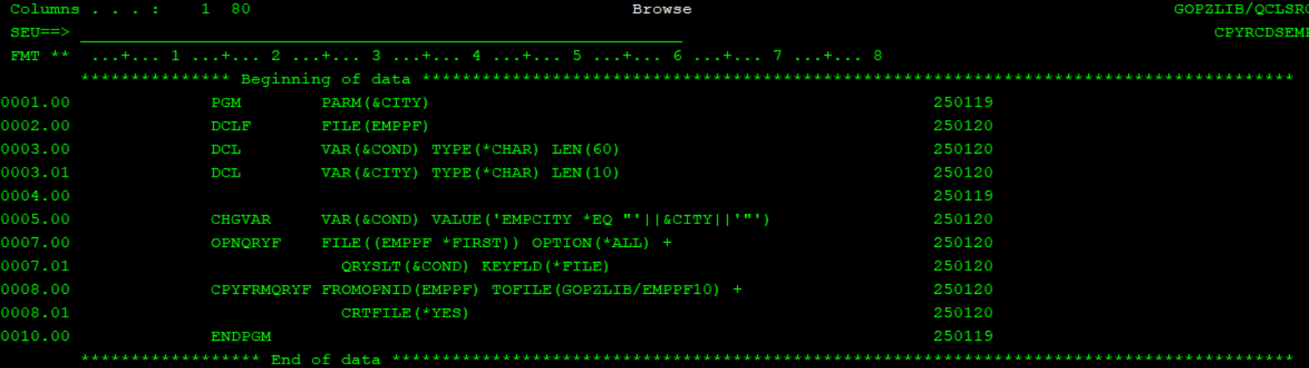

1. CREATE A CLP program to get city as parameter and write those records in emppf10 this write needs to happen in rpgle

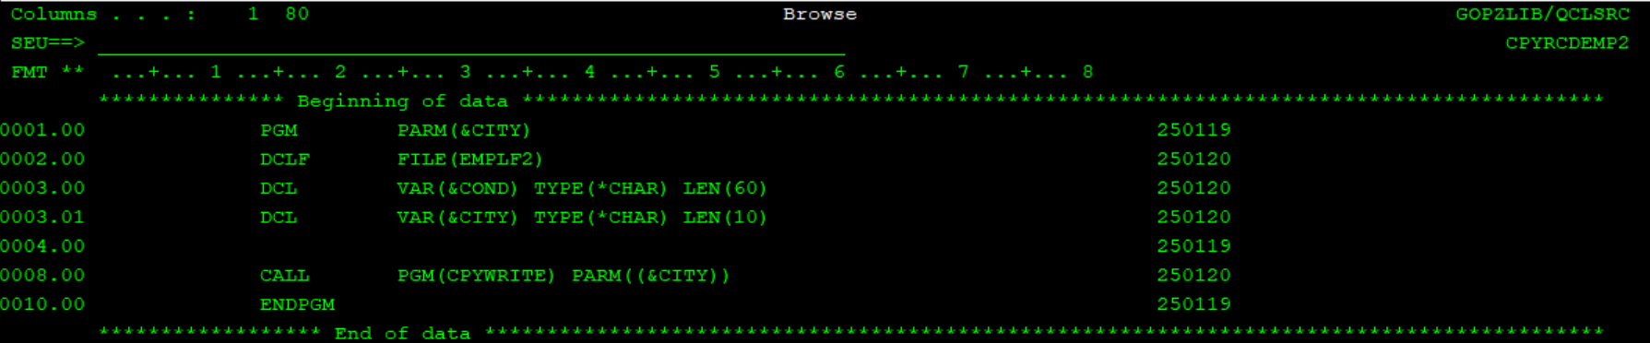

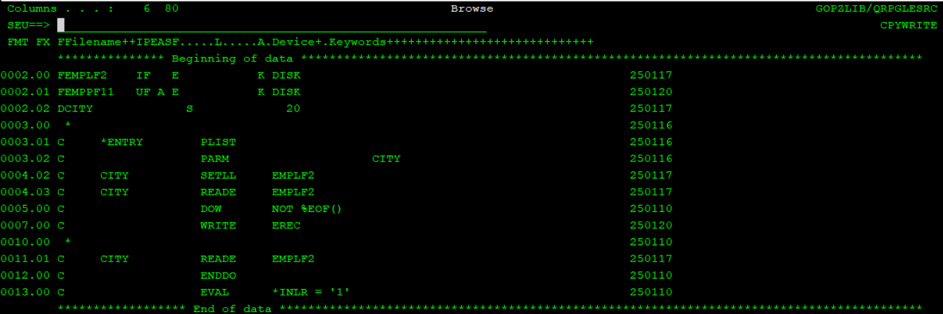

1. Create a file to implement command level error mngt

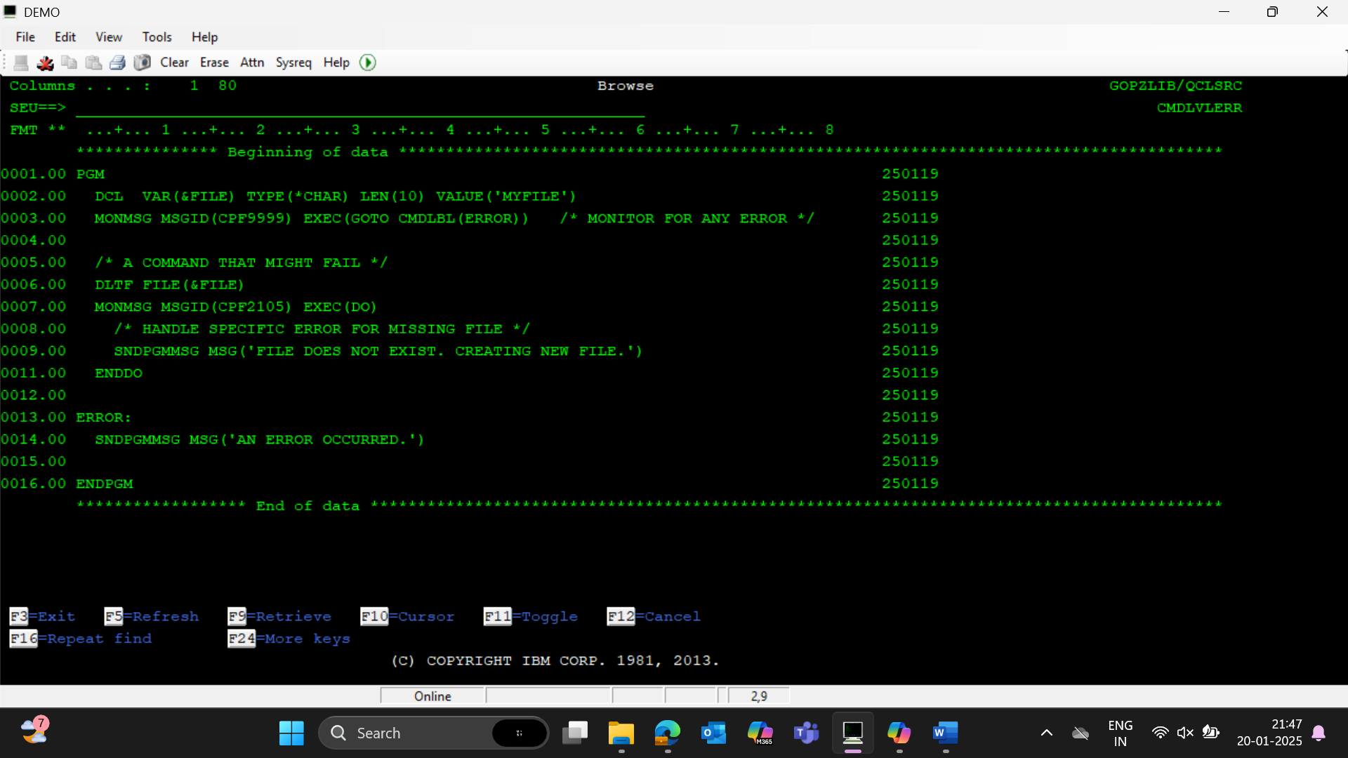

1. Handle error in cpyf command using default way

(Here, program level error)

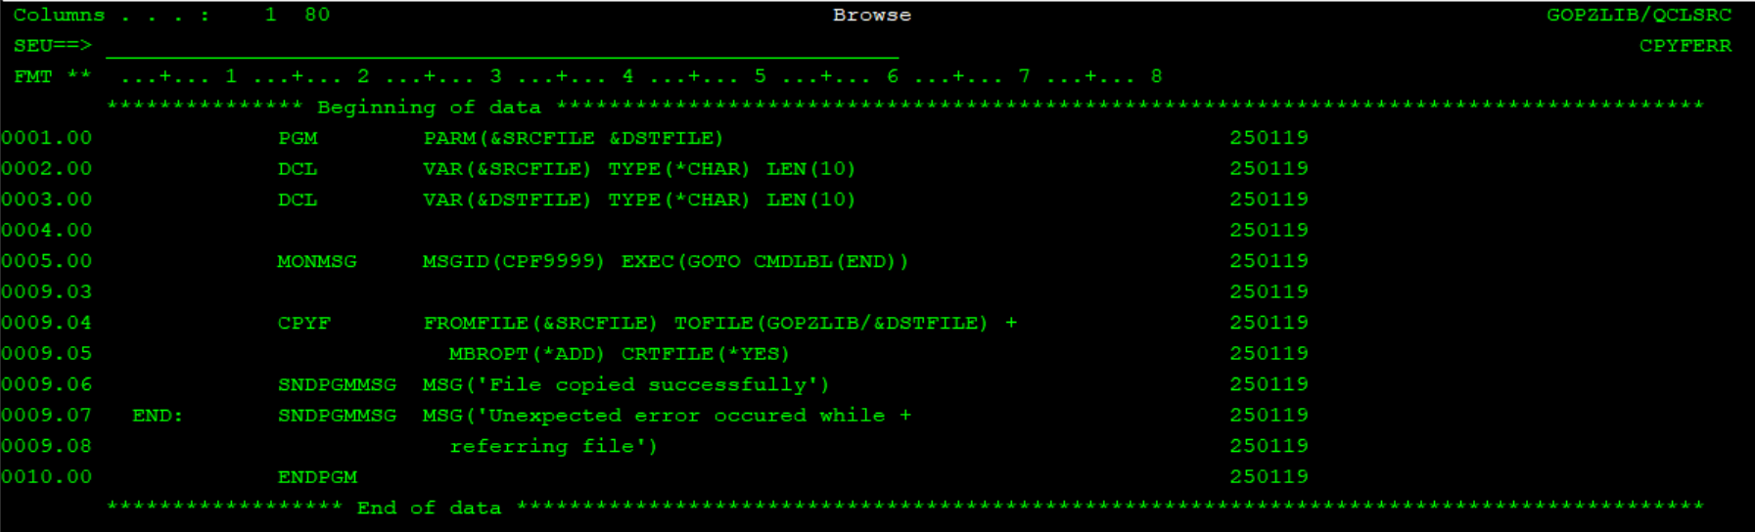

1. Handle error in cpyf command for flatfiles

(Here, command level error)

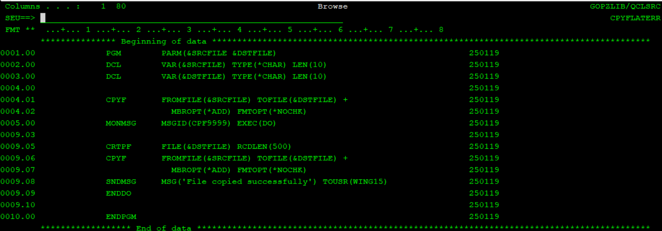

1. Employee names where city name starts with ‘T’

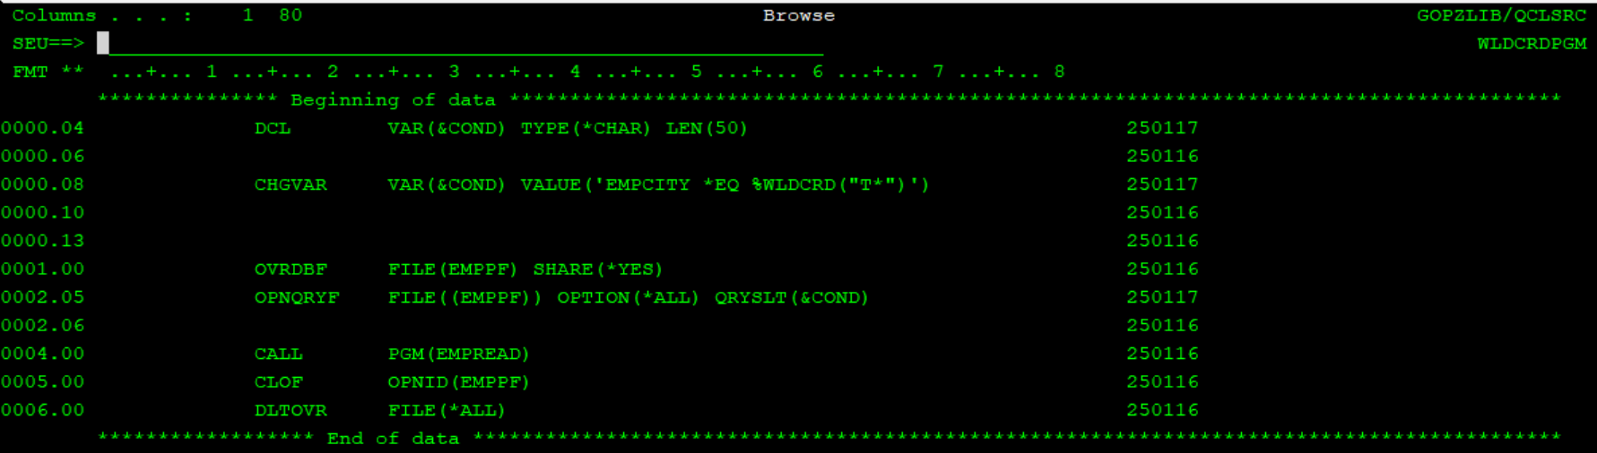

1. Employee names where city contains ‘T’

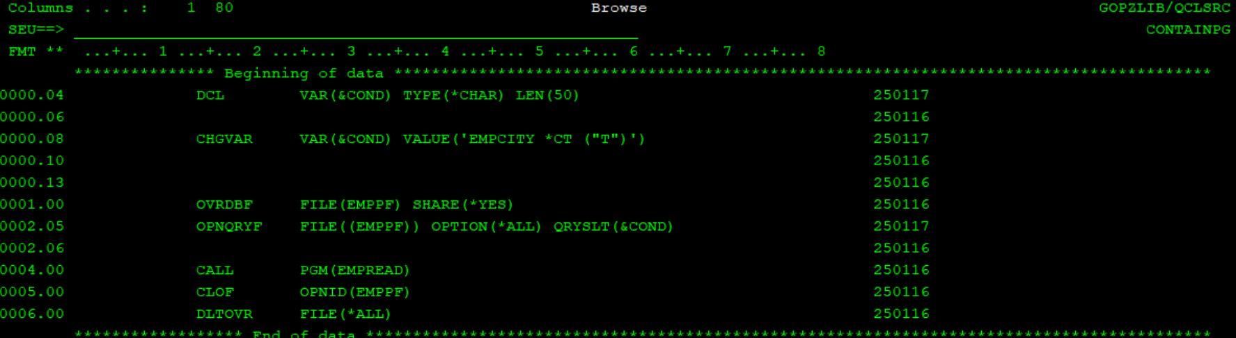

1. Generate report for employees whose empno is greater than 101

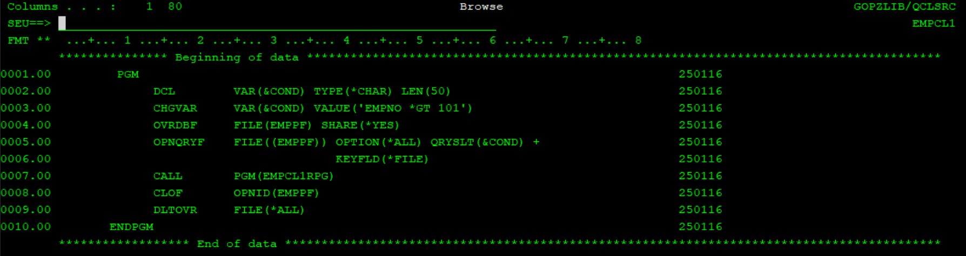

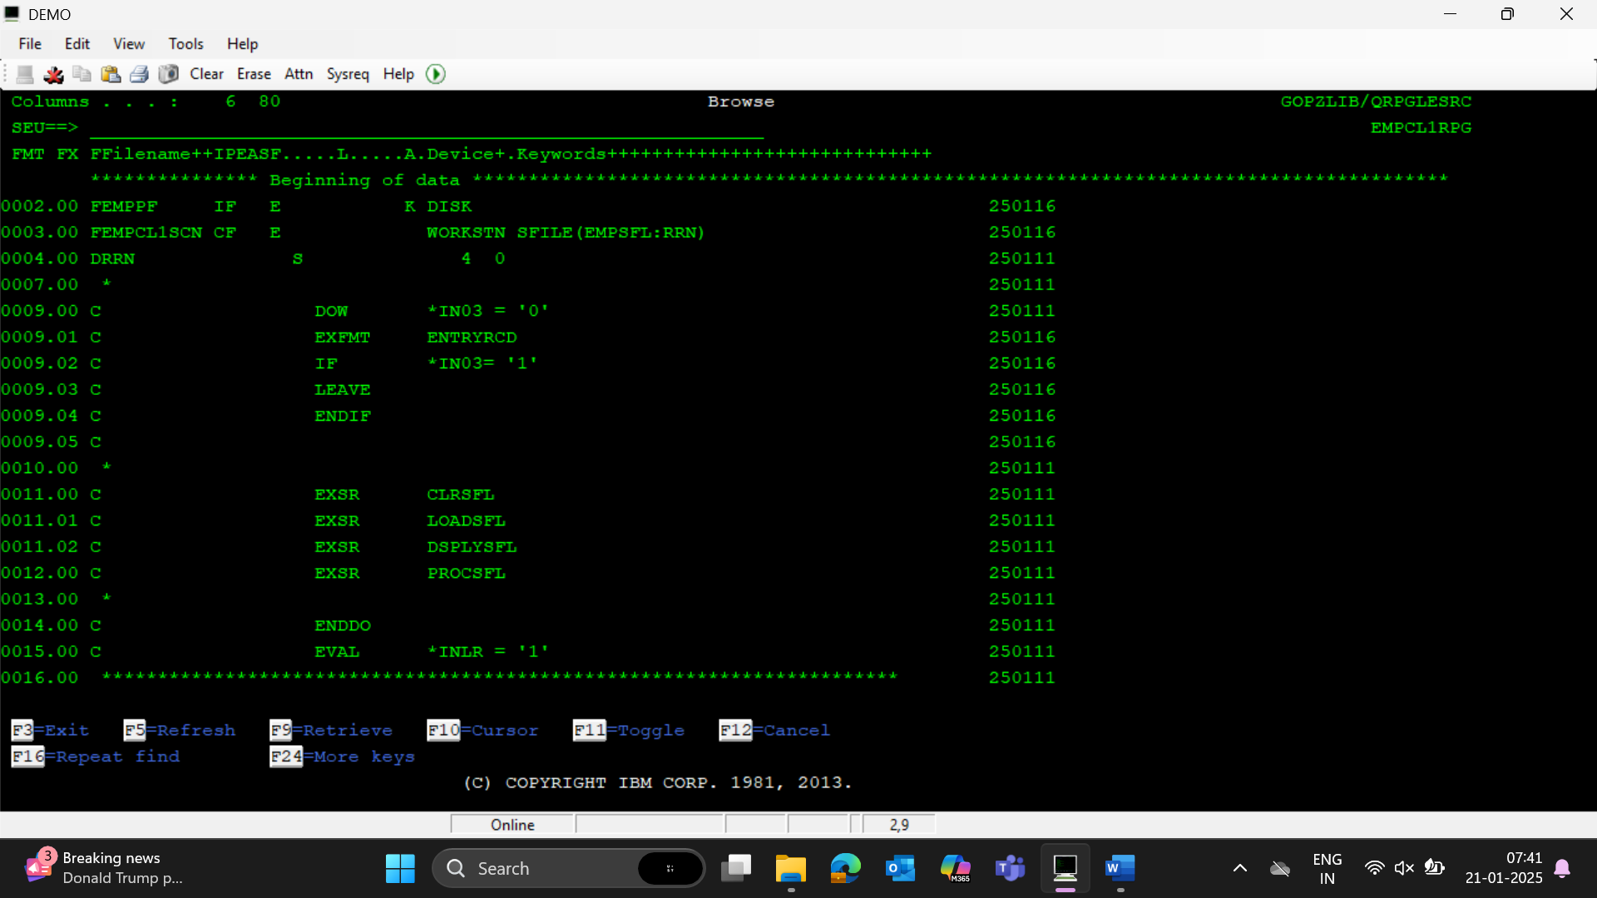

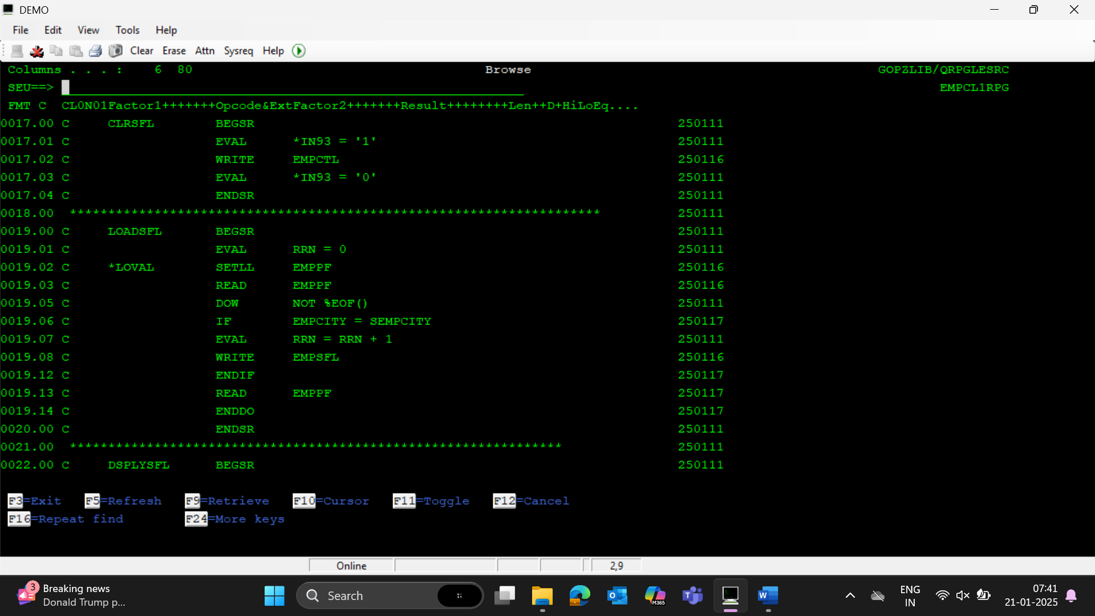

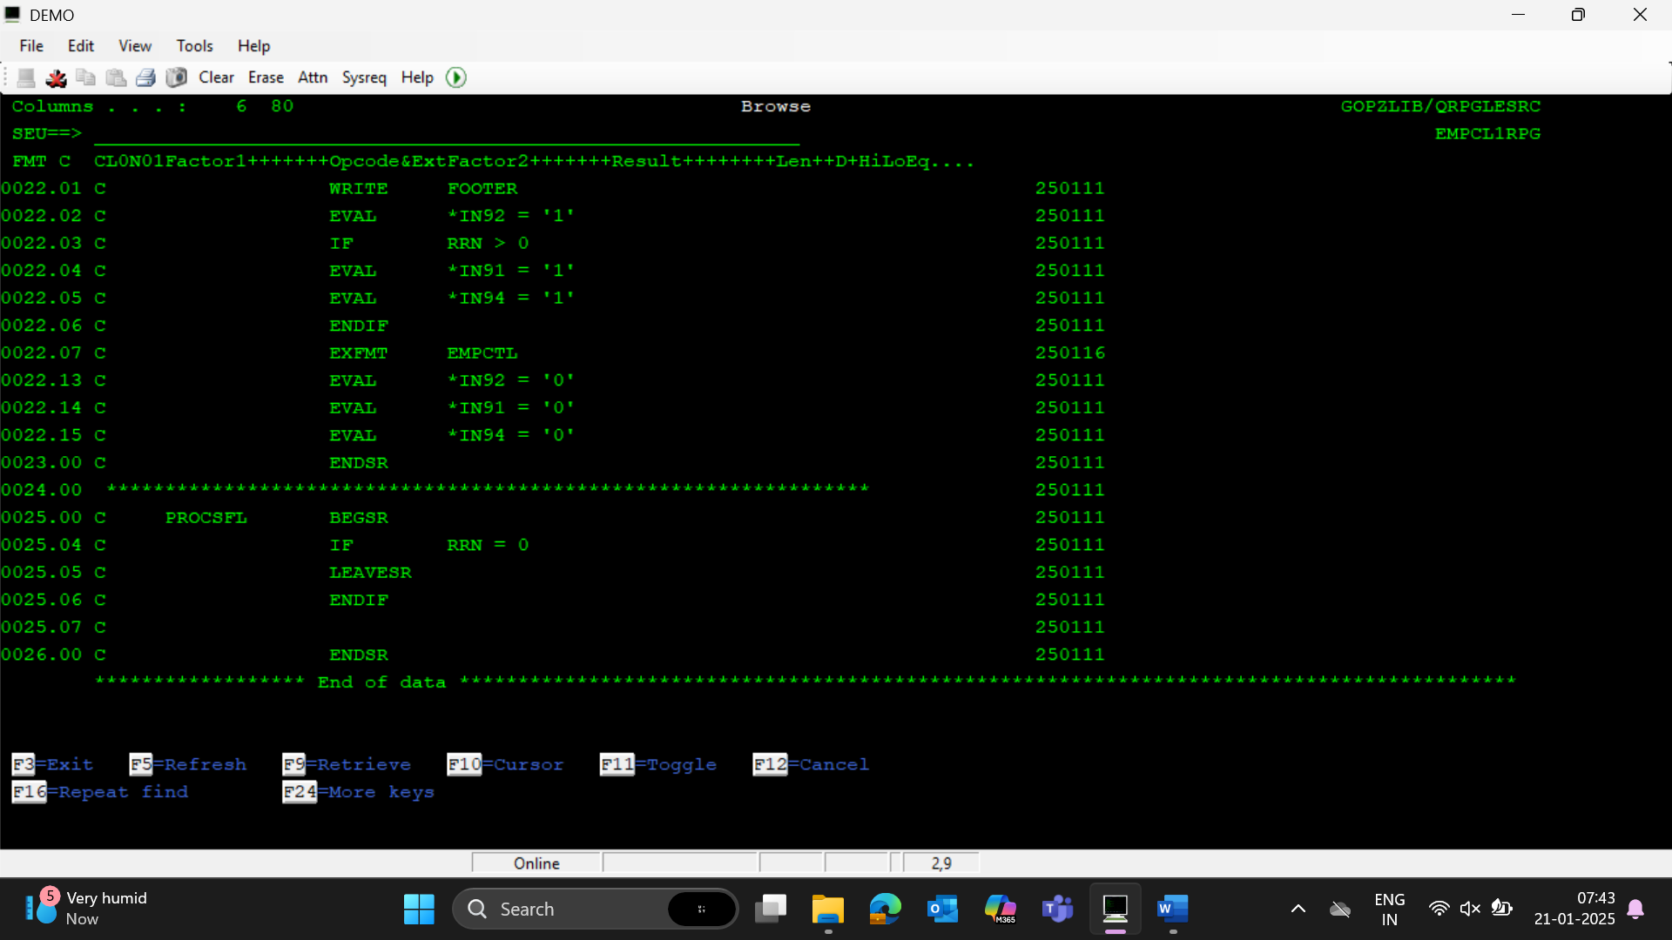

1. System date conversion

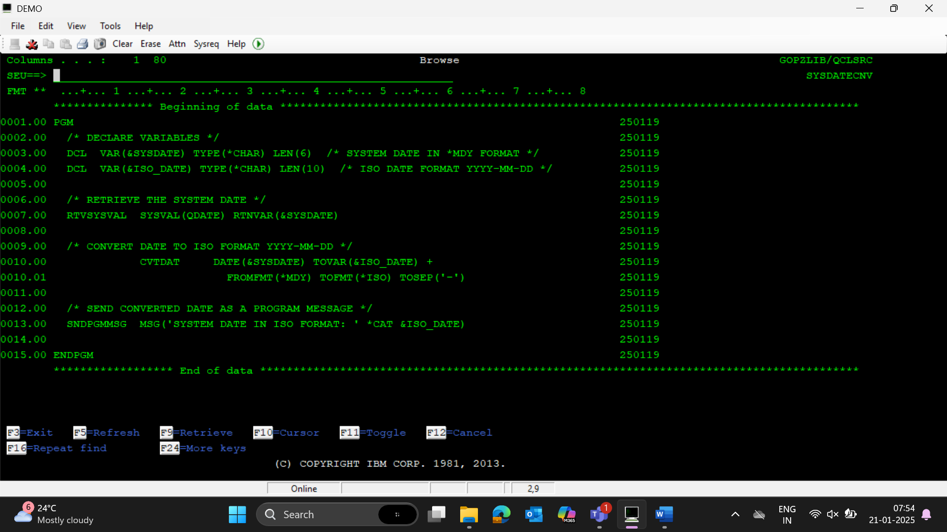

1. Screen1 (record format) will have only 1 field which is the Order date. When we enter an order date in the Screen 1 and hits Enter, screen 2 which is a subfile will display all the order details for the purchase orders which has the order date as the value entered in screen 1 and are shipped (ORDSHP = Y). Fields that should be displayed in screen 2 should be Order number, item number, item quantity and User ordered. Screen 1 should have the function key F3. Screen 2 should have the function keys F12 and F3. On hitting F12, should go back to Screen1. On hitting F3, should end the program.

Note: Add proper validations for the Date field in screen 1 and display appropriate error messages

The 1st screen should be displayed using CLP

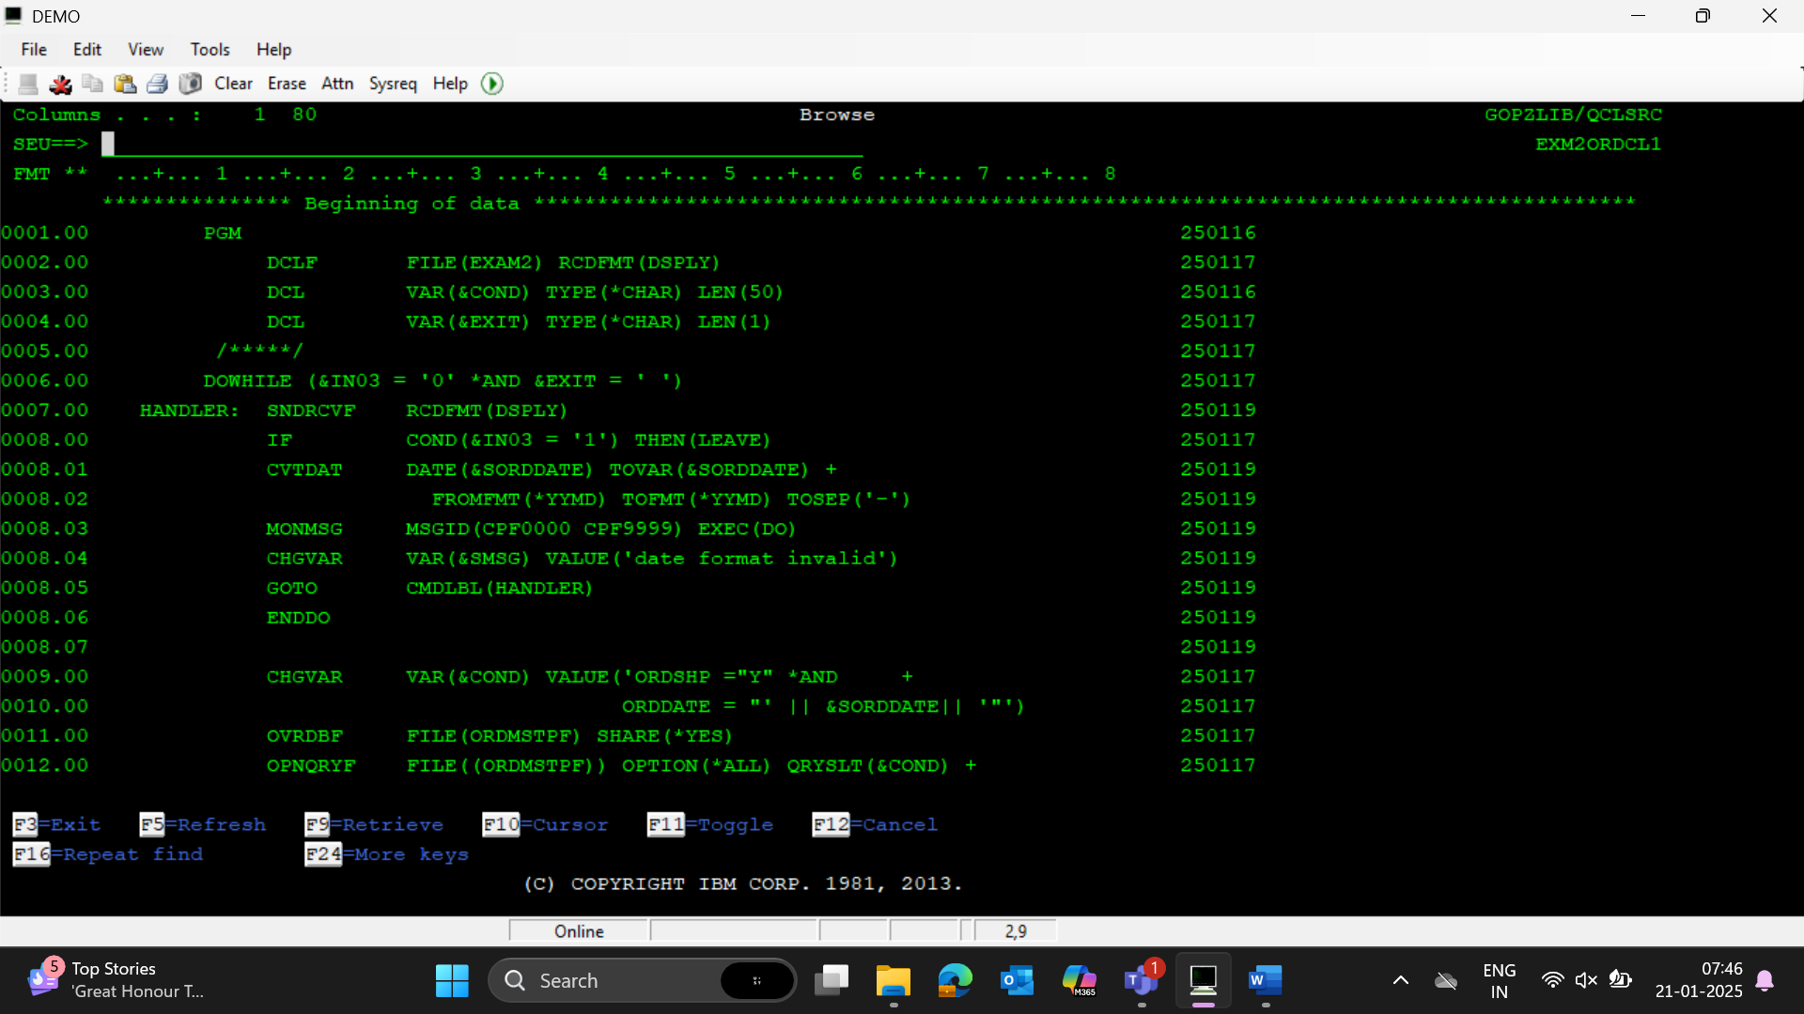

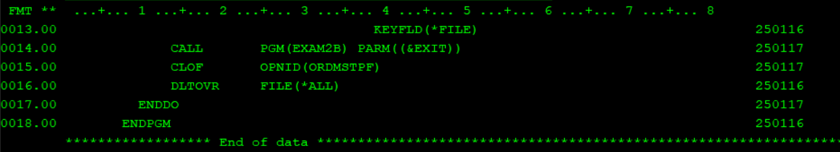

1. Overriding flatfiles

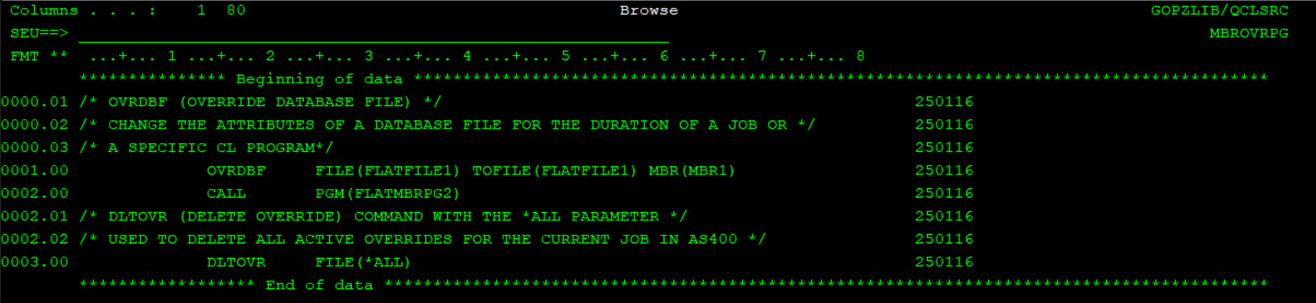

1. Overriding pf files

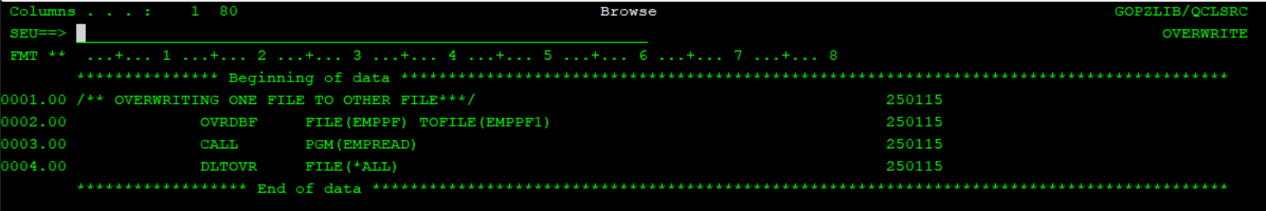

1. Override attr using OPNQRYF call empread

